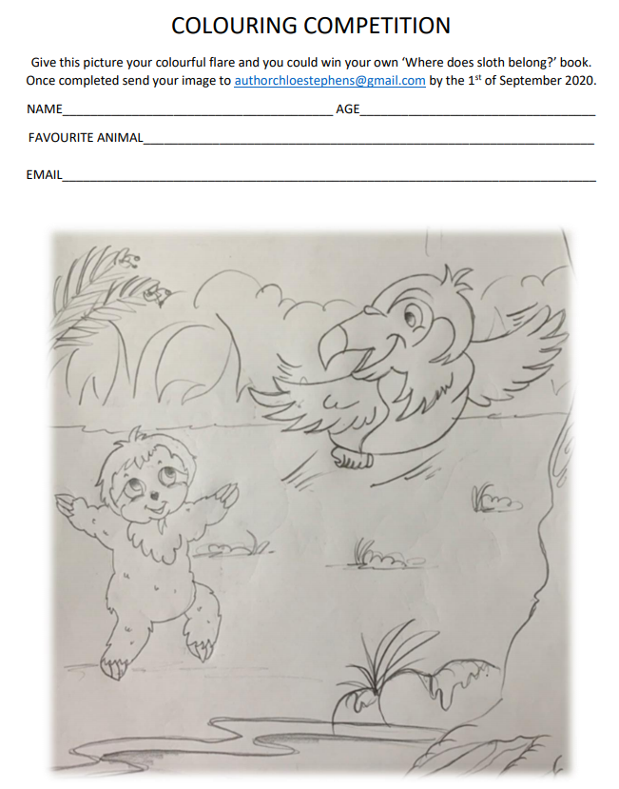

31 December 2020

*By submitting your entry, you consent to this image being used on our website and social media.*

Would you like to subscribe to Chloe’s mailing list for more competitions and updates? **YES/NO**

**GOOD LUCK**

www.chloestephensauthor.com